**Project Design Phase-II**

**Data Flow Diagram & User Stories**

|  |  |
| --- | --- |
| Date | 12 October 2022 |
| Project Name | Project – Classification of Arrhythmia by Using Deep Learning with 2-D ECG Spectral Image |
| Maximum Marks | 4 Marks |

**Data Flow Diagrams:**

A Data Flow Diagram (DFD) is a traditional visual representation of the information flows within a system. A neat and clear DFD can depict the right amount of the system requirement graphically. It shows how data enters and leaves the system, what changes the information, and where data is stored.

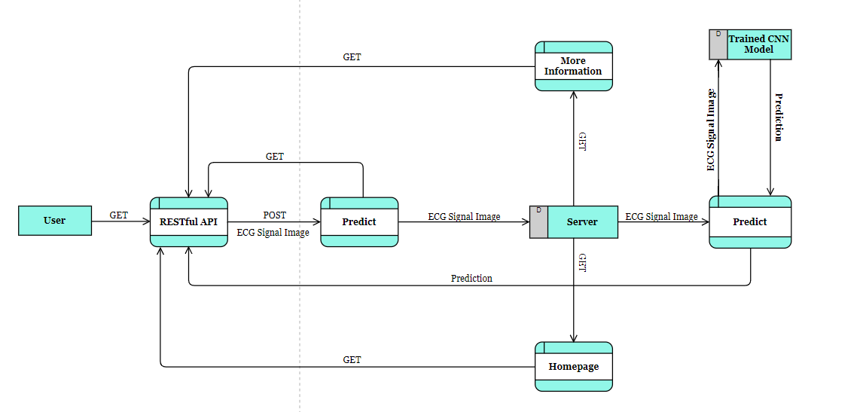

**User Stories**

| **User Type** | **Functional Requirement (Epic)** | **User Story Number** | **User Story / Task** | **Acceptance criteria** | **Priority** | **Release** |
| --- | --- | --- | --- | --- | --- | --- |
| Customer (Mobile/ Web) | Registration | USN-1 | As a user, I can register for the application by entering my email, password, and confirming my password. | I can access the site. | Medium | Sprint-3 |
| Customer (Mobile/ Web) |  | USN-2 | As a user, I will receive confirmation email once I have registered for the application | I can receive confirmation email & click confirm | Medium | Sprint-3 |
| Customer (Mobile/ Web) |  | USN-3 | As a user, I can register for the application through mobile OTP method | I can register & access the site via mobile OTP reception. | Low | Sprint-3 |
| Customer (Mobile/ Web) |  | USN-4 | As a user, I can register for the application through Gmail | I can register & access the site via Gmail. | Medium | Sprint-3 |
| Customer (Mobile/ Web) | Login | USN-5 | As a user, I can log into the application by entering email & password. | Successful login upon entering the correct credentials. | Medium | Sprint-3 |
| Customer (Mobile/ Web) | Homepage | USN-6 | As a user, the homepage must properly define the Arrhythmia, its causes and effects and understand how the application helps in solving the problem. | Thorough understanding of Arrhythmia, its types, and its side effects | High | Sprint-1 |
| Customer (Mobile/ Web) | More Information Page | USN-7 | As a user, I must be able to comprehend all medical jargon related to Arrhythmia such as ECG, Coronary Heart Disease, Cardiomyopathy and its types. | In depth knowledge of medical terms and being capable of explaining to a layman | High | Sprint-1 |
| Customer (Mobile/ Web) | Prediction Page | USN-8 | As a user, upon uploading an image of an ECG, I must get an accurate prediction of the class it belongs to. | Extremely high accuracy on the samples for the test set. | High | Sprint-1 |
| Customer (Mobile/ Web) | Results Page | USN-9 | As a user, I must be able to view the results of the classification. Also, I must also receive additional information about the type of arrhythmia. | Precise information about the types of diseases. | High | Sprint-1 |
| Customer (Mobile/ Web) | Contact Page | USN-10 | As a user, I must be directed to further sources of help which would help in the treatment process. | Verified sources such as specialist doctors, hospitals, grants etc. provided | Medium | Sprint-2 |